CN Assignment-02

Jeetu Mehra
U24AI032

Question 1 : Construct a virtual LAN in the Cisco packet tracer as shown below, and check where the data packets are transferring from one system to another.
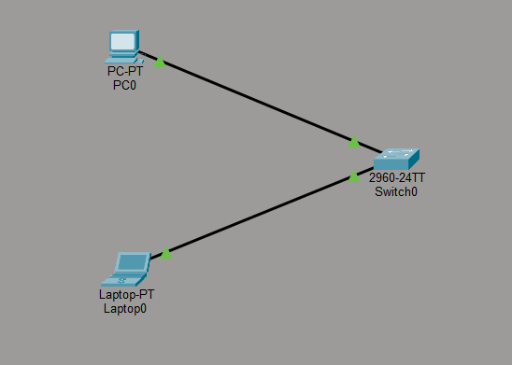
Output:

Question 2 : Construct a virtual MAN in the Cisco packet tracer, as shown below, and check where the data packets transfer from one system to another.
Output:

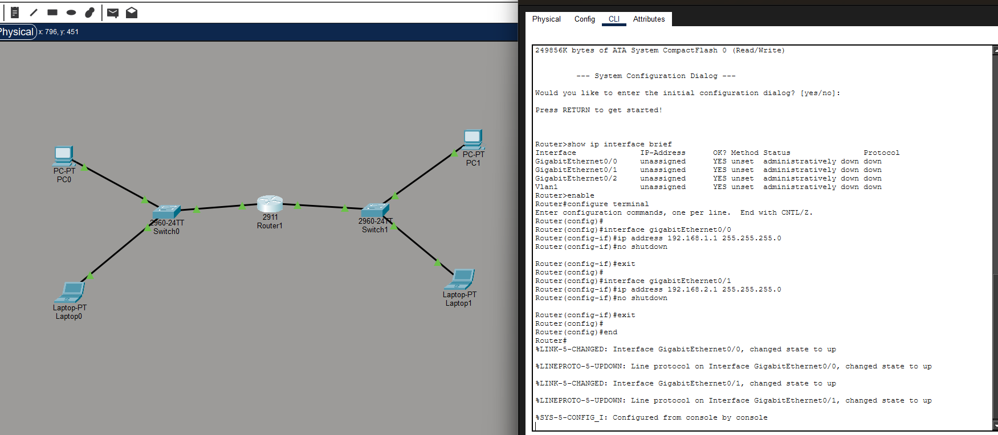

Question 3 : Construct a virtual WAN in the Cisco packet tracer as shown below, and check where the data packets are transferring from one system to another.
Output:
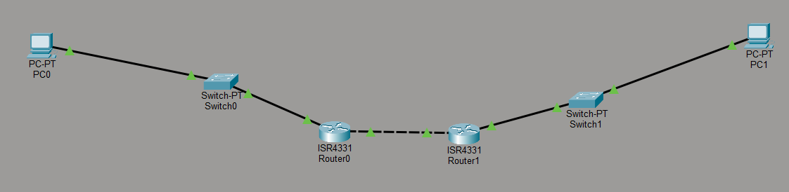
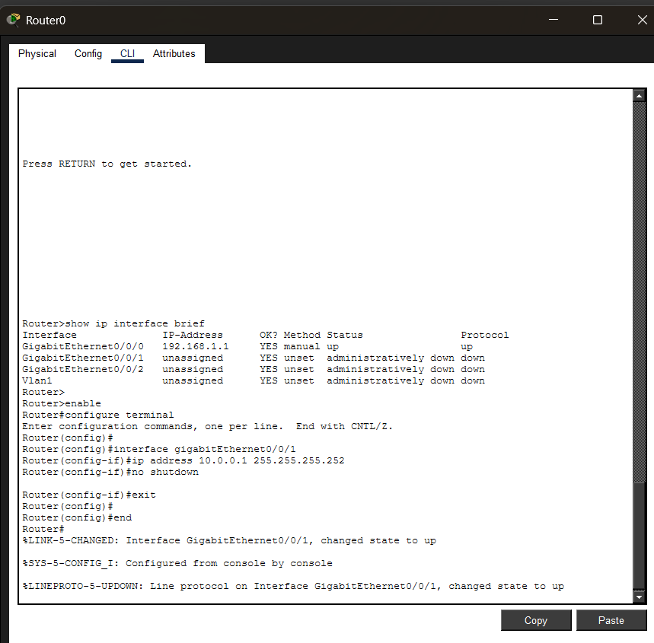

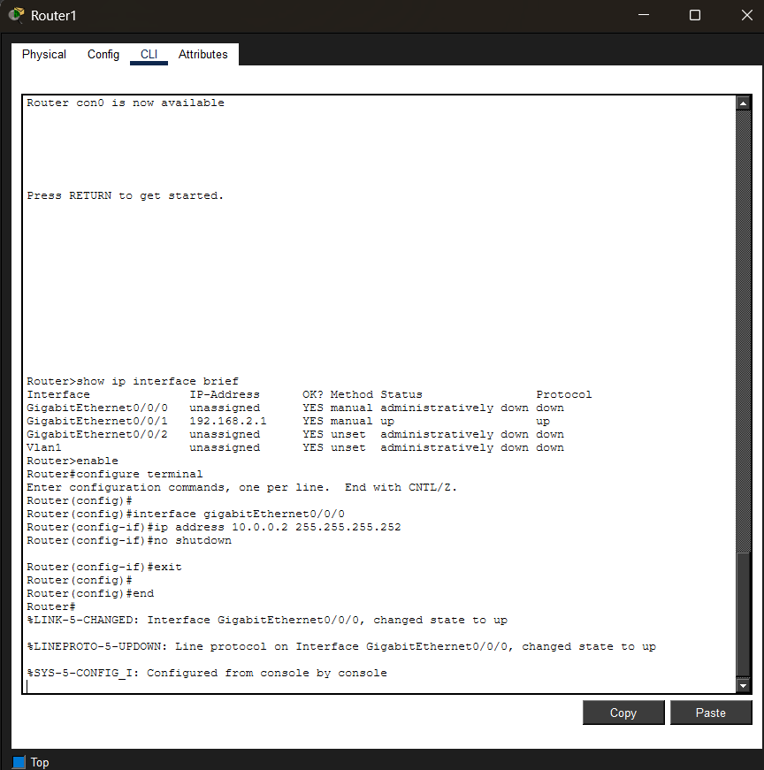

Question 4 : Construct a virtual WAN in the Cisco packet tracer as shown below, and check where the data packets are transferring from one system to another.
Output:
